**UNIVERSITY OF JOHANNESBURG**

|  |  |  |  |  |  |  |
| --- | --- | --- | --- | --- | --- | --- |
| |  |  |  | | --- | --- | --- | | **PROJECT NAME: TULEN** |  |  | |  |  |  | |

**FACULTY OF SCIENCE**

**ACADEMY OF COMPUTER SCIENCE AND SOFTWARE ENGINEERING**

|  |  |
| --- | --- |
| **COURSE NAME** | **INFORMATICS 3A** |
| **COURSE CODE** | **IFM3A10** |
| **COURSE TITLE** | **INTRODUCTION TO SOFTWARE ENGINEERING** |

|  |  |
| --- | --- |
| **INSTRUCTOR** | **MR F BLAUW** |
| ***TEAM*** | ***#15*** |

|  |
| --- |
| **DELIVERABLE ONE: REQUIREMENTS & ANALYSIS** |

|  |  |
| --- | --- |
| **NAME** | **STUDENT NUMBER** |
| **MAMIDZA RN** | **201439312** |
| **K bENTELE** | **215044265** |
| **MNDAWENI SG** | **201458217** |
| **NEKHAVHAMBE V** | **216023211** |

|  |  |
| --- | --- |
| SUPERVISOR NAME | T GOODBURN |

Table of Contents

1. BACKGROUND AND SURVEY/INTERVIEWS

1.1 INTRODUCTION………………………………………………………...…… 2

* 1. COMPANY/INDUSTRY BACKGROUND……………………….……. 2
  2. CURRENT SYSTEMS…………………………………………………………. 3
  3. DESCRIPTION OF METHOD FOLLOWED……………………………. 4

1.5 INTERVIEW / SURVEY STRUCTURE………………………………… 5

1. REQUIREMENT EXTRACTION
   1. FUNCTIONAL REQUIREMENTS……………………………………... 8
   2. NON-FUNCTIONAL REQUIREMENTS……………………………... 8

3. FEASIBILITY STUDY

3.1 SYSTEM FEASIBILITY………………………………………………………

3.2 TECHNICAL FEASIBILITY…………………………………………………

3.3 ECONOMIC FEASIBILITY…………………………………………………

3.4 OPERATIONAL FEASIBILITY…………………………………………….

4. IDENTIFICATION OF USE CASE & USE CASE DIAGRAMS

5. USE CASE DESCRIPTIONS

1. **Background and Survey/Interview**
   1. Introduction

While StatsSA have recently just announced an unemployment rate drop by 1%, the youth unemployment is still a tickling crisis for the nation. People who are supposed to be participating in the economy of the country are idle. Fresh minds that should come up with ideas to create jobs for others lack necessary resources to become entrepreneurs. It is an alarming concern that our education system is not equipping individuals to have stake in the economy, with majority of the youth inactive, the future of the country is in jeopardy. Unless the country can produce people, who can do something with their skills, unless those people gets to partake in the economy by either opening their own businesses, which creates more jobs, or by using their skills to earn a living, the economy will remain in shambles.

The education system is failing tremendously when it comes to teaching and training individuals who can be fully equipped after matric. According to the News24 article published on 2017-01-06 16:30 (<https://www.news24.com/SouthAfrica/News/sa-education-system-one-of-the-worst-in-the-world-the-economist-20170106>), South Africa ranked 75th out of 76. The article further states that 27% of South African learners who have attended school for the past 6 years could not read or write. In the field of mathematics, we are rated as one of the poorest in the world. The approaches that have been used so far have demanded lot of investment with little impact, while learners may pass and excel, the standard has deteriorated each year. Repetitive and misunderstood content limits the learner’s creativity at the level where their curiosity and creativity are to be stimulated mostly. All this hinders the full learning experience that a normal child should undertake. With the standard of our education, intelligence cannot be fully tested and improved.

* 1. Company / Industry Background

For many, knowledge and intelligence has been a strong pillar of any empire’s success. Education has been used to administer a moral code for the youth. There is a direct proportion in education and employment in any country and one greatest example is China. Any country with high illiteracy level is unlikely to attract investors. Africa is behind in education and it has prevented us from founding many things on our own. Even with minerals we own at our shores, we still do not have the necessary skill to make them a final product. Having learnt earlier than us, the westerners have capitalized on that opportunity to use what they know to enrich their countries (Bulhan 240).

However, back in the day, most Africans did not have a choice on education and in some other parts, it is still like that. With the modern-day technology, researches have advanced so fast and the way they are conducted have changed vastly. For a business to make it, a broad expertise on the field is required, and one must stand out to even just get a job. Every industry that is currently active requires some form of education to run smoothly. So, education is the industry that balances all industries, whether it is formal or informal, knowledge application is what working is all about.

* 1. Current Systems.

There are quite a few current systems in place with some doing a good job and some failing to get a breakthrough in the industry. All the systems however are not concerned about standard improvement, they are all just delivery systems.

* + 1. Extramarks.co.za

[Extramarks.co.za](http://www.extramarks.co.za) is a premium platform that allows a user to either register as a teacher, parent or learner. For minors, a parent can register on their behalf and anyone above the age of thirteen can have their own account. However, the fact that the system is not free, it discourages many users to desire using it, especially learners who do not earn any money and rely on allowances. By using subscriptions, the system limits the period in which learners can use the system. The system is not a good option for a developing nation like South Africa.

* + 1. Mytopdog.co.za

[Mytopdog.co.za](http://www.mytopdog.co.za) is a more powered version that is part of the Vodacom e-school initiative. The system is user friendly and details everything very easy. It is also a premium system; however, it does not cater for all subjects, it serves mathematics above all other subjects. For a premium system and what it offers, it is worth it, however, those who cannot pay are still excluded. The system using a team of actuarial and data scientist to assess learner differences. However, the system does not react to the differences, only the scientists solve that problem and tell the system which tutor to assign to which learner. It is expensive to use actuarial scientists physical and for the fact that people can do it, it shows that the site does not have many users.

* + 1. Lynda.com

One of the high rated systems in use to date is [Lynda.com](http://www.lynda.com). The system covers hundreds of courses and contains quality premium tutorials. Instead of paying for that subject, Lynda.com accepts payment for a specific tutorial video, however, users do have an option to pay for the whole course content. The system however only covers the tertiary level content. Being a foreign system, it would be hard for it to be compatible with a South African syllabus.

* + 1. Coursera.com

One of the most successful online education system of all time, [Coursera](http://www.cousera.com) is user friendly, intuitive and very beneficial to any user. The system connects to online courses from many global universities, at its foundation, it was a free system, however, to encourage users to finish their registered courses, it became a premium system. The system allows users to register to any online course of choice, no prior qualification is required. Upon completion, user gets a verified and most cases accredited certificate of completion. The system however is also for tertiary level only.

* 1. Description of Method Followed

Our major stakeholders are learners and teachers, the priority was to extract information from those people and see if we could be on the same page about the problem we claimed that they are facing. The purpose of our questionnaire was therefore problem extraction. We provided our stakeholders with the list of problems to see if they agreed with us or not. By allowing them to justify their decisions, they provided insight on what the real problem is. One approach we used for our survey was visiting different school from four completely different locations. This ensured that we do not only survey one pool but do so in different pools to validate the trends and patterns in our results. It is more likely that learners from the same area and school have similar problems, however, it is unlikely for learners from different schools and area to have the same problem.

The method used to gather information from stakeholders included distribution of online forms and paper based interviews and surveys. However, the paper based was more reliable we could see the people who responded to our surveys. The main reason was personal contact, with personal contact, our stakeholders were more open and free to ask question and provide insight that was not included in the questionnaire suggestions. It also allowed us to build a relationship with our stakeholders and see how they personally feel about the problem we are solving.

* 1. Interview / Survey Structure

*Survey*

Learner Survey Questions and Results.

|  |  |  |  |  |  |
| --- | --- | --- | --- | --- | --- |
|  |  | Strongly Agree | Agree | Disagree | Strongly Disagree |
| 1 | *The current approach and syllabus change has proved successful* |  |  |  |  |
| 2 | *System give you information beyond the syllabus scope.* |  |  |  |  |
| 3 | *You do not need extra source of information besides your teacher and subject books.* |  |  |  |  |
| 4 | *You can speak more than one vernacular language.* |  |  |  |  |
| 5 | *You can communicate effectively in English.* |  |  |  |  |
| 6 | *You can read and write one or more foreign language.* |  |  |  |  |
| 7 | *You spend satisfactory amount of time communicating in language that is not your home language.* |  |  |  |  |
| 8 | *You have access to prescribed language books and dictionary.* |  |  |  |  |
| 9 | *You understand media coverages like newspapers, radio, television and magazines.* |  |  |  |  |
| 10 | *You understand why you should learn mathematics.* |  |  |  |  |
| 11 | *You can communicate effectively with mathematics as a language.* |  |  |  |  |
| 12 | *You can solve complex mathematical problems.* |  |  |  |  |
| 13 | *You can perform arithmetic beyond 100 well.* |  |  |  |  |
| 14 | *Understand what fractions are and enjoy working with them.* |  |  |  |  |
| 15 | *Can factor numbers or equations well.* |  |  |  |  |
| 16 | *Inspired to understand numbers or equations deeper.* |  |  |  |  |
| 17 | *Can understand applications of technology in real life.* |  |  |  |  |
| 18 | *Can raise challenging questions about technology creation and application.* |  |  |  |  |
| 19 | *Can hypothesize and investigate without teacher supervision.* |  |  |  |  |
| 20 | *Can interpret information provided from an investigation?* |  |  |  |  |
| 21 | *Can draw out a correct conclusion from the information gathered from of a research.* |  |  |  |  |
| 22 | *Can communicate using models and other visual tools.* |  |  |  |  |
| 23 | *Understand most basic elements of science* |  |  |  |  |
| 24 | *Understand basic economic system elements.* |  |  |  |  |
| 25 | *Can handle basic accounting concept well.* |  |  |  |  |
| 26 | *Can apply basic business management skills practically.* |  |  |  |  |
| 27 | *Understand entrepreneurship and how to become an entrepreneur.* |  |  |  |  |
| 28 | *Can link existing political events to the past events.* |  |  |  |  |
| 29 | *Have read about two or more wars.* |  |  |  |  |
| 30 | *Understand how the systematic behaviour of the planet.* |  |  |  |  |

Teacher Survey Questions

|  |  |  |  |  |  |
| --- | --- | --- | --- | --- | --- |
|  |  | Strongly Agree | Agree | Disagree | Strongly Disagree |
| 1 | *You are satisfied with the current way of teaching.* |  |  |  |  |
| 2 | *The learners are always well prepared for the class or new topic.* |  |  |  |  |
| 3 | *Learners have access to what they will be doing for the term.* |  |  |  |  |
| 4 | *Learners need more teaching than they receive.* |  |  |  |  |
| 5 | *Learners are different, and they need different approaches when it comes to teaching.* |  |  |  |  |
| 6 | *Parents need to be involved in their child’s education* |  |  |  |  |
| 7 | *If learners knew beforehand what they need to know for the term it would improve their learning.* |  |  |  |  |
| 8 | *Learners are capable of learning by themselves that’s if they have another source of learning.* |  |  |  |  |
| 9 | *Learners need more than what they get in class.* |  |  |  |  |
| 10 | *It is possible to improve teaching therefore improve learning.* |  |  |  |  |

Interview Questions

1. Do you think there is way to improve learning?

|  |
| --- |
|  |

1. If your answer is yes for 1, then what would be that way but if your answer is no, please elaborate.

|  |
| --- |
|  |

1. Do you think if there is a good communication between teachers, learners and parents there would be a difference in the way a child performs?

|  |
| --- |
|  |

1. Do you think a child in grade R can benefit from using and App in a phone for learning?

|  |
| --- |
|  |

1. What can be changed in the current way of learning?

|  |
| --- |
|  |

1. Can a learner benefit from any other source of learning? If yes, then how? If no, then why do you say that?

|  |
| --- |
|  |

1. For High school learners even primary school learners, do you think using the phones or laptops or tablets will be a distraction in their learning? Please elaborate.

|  |
| --- |
|  |

1. If your answer is yes for 7, how do you think that can be avoided?

|  |
| --- |
|  |

1. If learners knew what was expected of them there would be a huge difference in their performance? Elaborate.

|  |
| --- |
|  |

1. Using different ways to approach a problem can affect a learner’s understanding of the solution?

|  |
| --- |
|  |

**2. Requirements Extraction**

2.1 Functional Requirements

* **Student can access learning content.**
* **Learners make comments to their own work.**
* **Enable the student to write a test.**
* **Allow the student to view their marks and corrections after each test.**
* **Allow the student to assess their progress.**
* **Allow the learners to collaborate with other learners.**
* **Administrator can create grade**
* **Administrator can create subject**
* **Administrator can register the student.**
* **Learners can ask question at any time to their teachers.**
* **Teacher can upload relevant information.**
* **System must notify the student of any new information uploaded by the teacher.**
* **Parents can send message to teachers.**
* **Teachers can send messages to parents.**
* **System asks question to learners based on what they been studying.**
* **Tutor system stores the learning content.**
* **Communication evaluation query for topics that learners can discuss.**
* **Teacher can create exam scope in the tutor system.**
* **Testing system generates memorandums for tests taken.**
* **System groups grades in phases {Junior, Intermediate, Senior and FET}.**
* **Learner selects a study phase to be tutored in.**
* **Teachers can add learners to their classes.**
* **Make sure learner does not participate in class they are not in.**
* **Ensure that the memorandum is not viewed or shared among peers.**
  1. Non-Functional Requirements
* **User Privacy.**
* **Legal consent on content acquired.**
* **Citation on content displayed by the system.**
* **Content alignment with the curriculum.**
* **System legally abides to South African education policies.**

**3.Feasibility Study**

3.1 Technical Feasibility

Technical support

For us to be able to develop the software we will need to know the curriculum and the content that is currently taught at school from Grade R to 12 and we also need different teaching technics. We will develop the system to display content or to tutor the student using a web application that will be created with an integrated development environment called visual studio 2017.the IDE was created by Microsoft we chose this IDE because it has disposable resource such as entity framework.

The system should be able to run in any basic desktop/laptop computer running windows 7 to 10, Mac OS 10.1.1 and Linux with an internet connection and a web browser should be installed. We will also use the web browser such as Chrome, Edge and Fire fox to test the application during the development of the system application.

As for the mobile application the student must have a smart mobile device that uses android from 4 to 8. To develop the mobile application, we will use android studio as an integrated development environment.

As for the languages the team decided to use C#, CSS, html, java script and java for the mobile application development.

System Feasibility

**Similar Systems:**

**Extramarks SA**

In this system a learner or school can register to the website. They have three things they focus on learn, practice and test. They use games and thematic pedagogy for junior learners and they hierarchical layered methodology for the senior learners.

**Vodacom e-school**

It provides learning everywhere using your smart phone, tablet or desktop computer. It also provides videos for learning. They also give learners tasks to do after the videos and they also evaluate the work the learners do in each subject. You also get rewards for progress.

**Kip McGrath Benoni**

They teach kids in grade R to grade 12, they only teach them English and mathematics, but it provides one on one personal time with the tutor or in small groups. It also provides computer-based activities.

Similarities:

All the users in this system will have to register to the website, but when it comes to the learner, it will depend on the age of the learner. From there on they can just login with their user name and password.

Tests, exercises and discussions will be conducted in this website also. The learners will get their results after the tests and know also where they went wrong. For the tests, exercises and discussions that a learner does there will be simple awards which encourage a learner to do more.

This website also does not contain any ads as it distracts learners in their learning. It easy for anyone to get distracted especially learners and getting back to focus is not easy.

Also provide a lot of visual learning especially for the learners who are still in primary school.

Provides easy navigation which makes it easy for primary kids to use the system. Educational systems that cater for learners in primary school have easy navigation as a learner can be as young as 7 years old therefore easy navigation is necessary.

3.3 Economic Feasibility

The idea of the Tulen educational system came about to minimize the high levels of poverty in South Africa. We figured that for us to tackle such a huge problem, we should go small and understand the root cause of such an unemployment rate. There is a lack of skill in the economy. Skill is acquired through teaching and knowledge. We determined the problem is with the education we give the young adults and the general youth. Hence, teaching the children and equipping them with the correct standard of education would have a positive impact on the broad problem.

This economic feasibility study will investigate the costs and benefits of the Tulen system because these two concepts are interrelated and often interdependent. This analysis aims to objectively and rationally uncover the strengths and weaknesses of this system.

## Forecasting

The variables to consider when building the system includes the costs of research for the content the system will teach. This includes the cost of textbooks and other resource that we’ll need to acquire for implementing the system correctly and accurately. Extra costs arise as the system is being developed, these costs may be the cost of the logo design for the system and the group. Other costs that may be incurred include the cost of transportation in the process of finding personal feedback from sponsors and end users.

The system is likely to generate a revenue, that is because it gives value to the student. The industry has similar systems but none of which teach Grade R to Grade 12 learners in one compact system.

### Estimation of trends

From the research we gathered from students, this system will likely grow in popularity as each student has pointed out that if they had such a system, they might recommend it to a fellow classmate and to a younger sibling as well. This will depend on the on exposure of the system and how we market it. As to where we market it does not matter much because every township and rural area has a decent internet connection.

## Identifying Benefits and Costs

### Tangible Benefits

The tangible benefits include generating revenue from a system that can be accessed by everyone with just a mobile device and an internet connection. The system will be made affordable even for the children attending schools with a substandard education in the rural areas and township. The system will also benefit student doing Grade R by providing an easy to use user interface that will be interactive and appealing to young minds.

Users will have access to the content daily, day and night. The information will be timely and accurate. Students can also be able to track their progress and what they lack in.

### Intangible Benefits

By providing such a system, we can dramatically improve the results of the student across all grades, and have a powerful impact on the future of the learner and ultimately the South African economy. The system will provide a competitive edge to existing systems in the South African digital market. This is beneficial to us because the current systems do not solve the underlying problem of unemployment. The “Bigger Picture” of this system is to get primary and high schools to integrate this system with their syllabus and education, and at the same time putting all students using this system at the same standard of education.

### Tangible Costs

The system will be subscription-based. Students will have to subscribe per month or per year for their grade. This subscription fee will be invested in the content being taught as it will need to be renewed and improved from time to time. This means money will be spent also on education content and research.

Costs will be spent on computer equipment and software for the improvement of the system to increase user experience.

### Intangible Costs

If this system is not implemented properly as we imagine it to be, then it is going to lose a competitive edge. That will have a negative impact in intangible costs. The overall system may be a fail which results costs lost in the form of time and money invested on the system.

3.4 Operational Feasibility

Software Reliability.

With the government now implementing the e-class initiative in various schools across South Africa, many teachers and learners are becoming computer literate. This sets a perfect environment for our system to be put in place. The eradication of chalk boards in those schools means that everything is computer based, except for writing process which will always require a pen and a paper at some point. With unlimited internet access in those schools, the system will not hinder and or disturb the learning process. Should it happen however for the internet to be down, the system could still capture all the information using wireless connection method like Bluetooth. With tablets distributed in classes and not allowed to go out. It will be easier and cheaper to use Bluetooth connection in case the internet shuts down. This will ensure that learning is not slowed down by any factor or operational disturbance that might occur.

Maintainability.

Our main goal is to teach children as early as grade R. Therefore, catering content for all learners from grade R to grade 12 is not the same. Even the teaching approaches differs for those grades. Which is why our system will be more interactive for learners and flexible enough to handle almost any action within a specific domain. We understand the curiosity of young minds; hence we should provide a system that is playful and easy to use for those minds. Our approach is to make the system more figurative for junior grades and make it more informative for senior grades upwards. Learners learn a lot quicker when they can see what they are learning about. Things like story telling should include drawings that are relevant to the text being read. If learners can learn objects quicker, it will be easier for them to learn to read and write. However, lot of teacher’s functionalities will be automated to save time in class without compromising what needs to be done. This will push the system to fit in into the work schedule of teachers and learners easier.

Affordability.

Our system is an educational system, not a school management system, however, such functionality is just an addition into the evolution of our system. By catering educational content, it is more like an online school accessible anywhere at any time. With more and more people connecting to the internet, our system can be accessible by all learners and teachers at a click of a button and free of charge. Our decision for making the system free is that the highest unemployment rate and poverty resides in previously disadvantaged areas. Which is why adding costs defeats the whole purpose of the system. Most households in South Africa have access to at least one smartphone. Which is the reason why our system is affordable by many South Africans.

Institutional Culture.

The system does not enforce standards and rules on how to run an institution, instead, it does not manage the institution, the system is meant to aid and amplify productivity in both teachers and learners. As such, the way the system operates depends on the person using it. However, a good and productive system should not go against the institution culture at any point if possible. This allows the users to adapt and accept the system easy. Hence our aim is not to change what teachers do. In one of the school we surveyed, most teachers felt uncomfortable about the idea of fully powered technology in class, some feel like it competes with what they do, however, there were those who believed that learners should have access to tutors and more communication with teachers more. Which is the reason our system is more learner oriented than teacher oriented. To avoid teachers and system competing against one another, the system must only assist teachers in class administrative work and communication. As for learners, the system allows them to schedule their work based on school rules and policies.

Overall

Though the system contains educational content to help learners with their problems, data is key in helping the system assist learners efficiently. A system that is like a personal educational mentor is priceless for learners. The system will encourage learners to input their marks for each class and home activity to aid the system to help learners better. However, such data is also priceless for teachers who do not have time to collect class and home tasks to evaluate the progress of their learners. By providing such, teachers will ensure that learners do this all the time since it will also help them learn more about the progress of their learners.

**4.IDENTIFICATION OF USE CASE & USE CASE DIAGRAMS**

4.1. Class Management Subsystem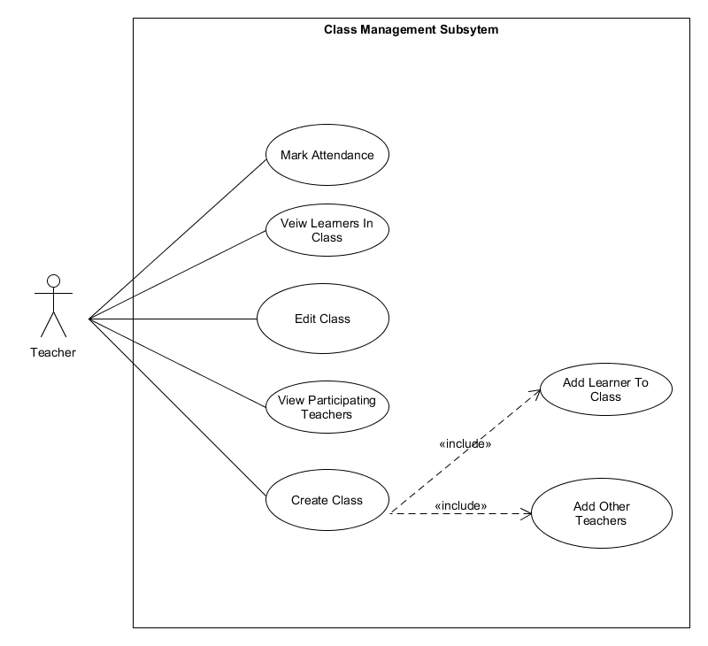

4.2 Communication Subsystem

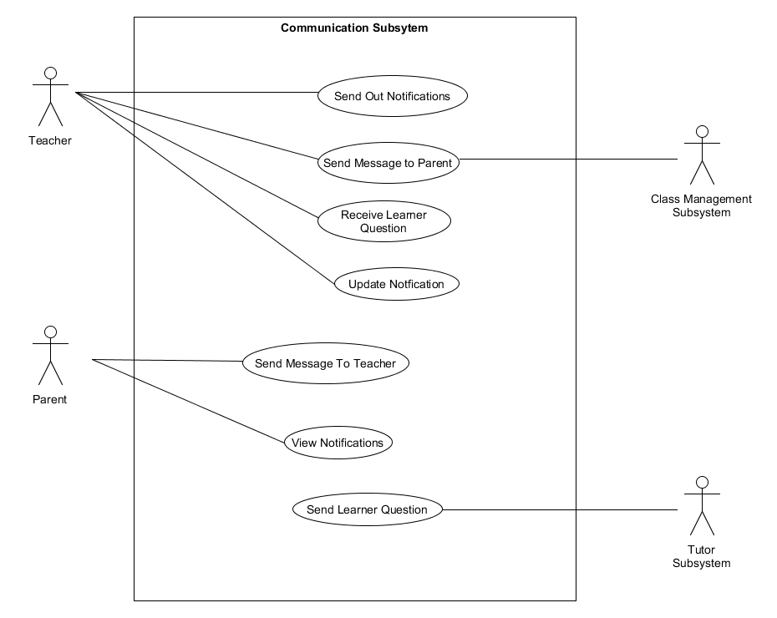

4.3 Communication Evaluation Subsystem

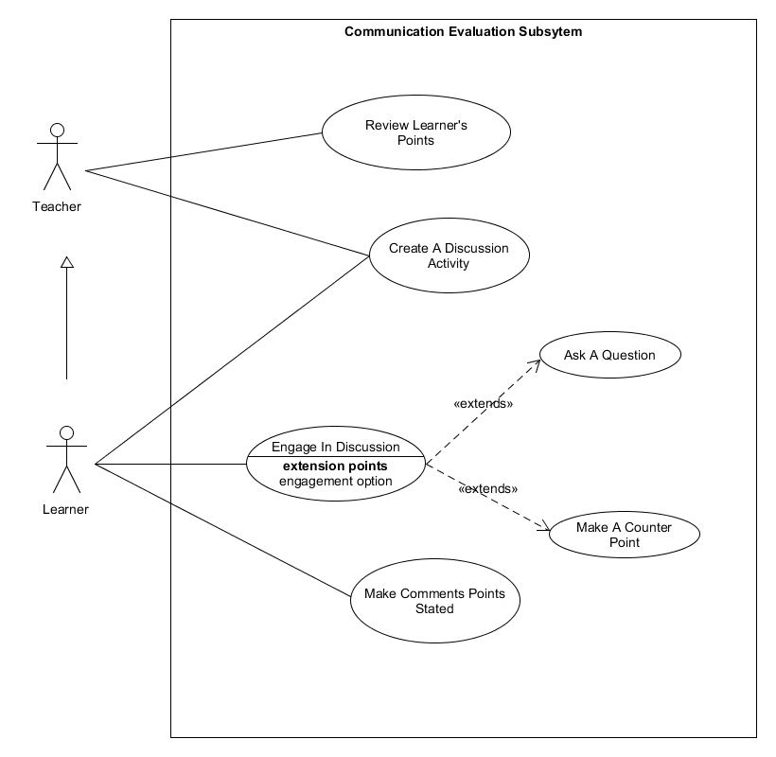

4.4 Content Management Subsystem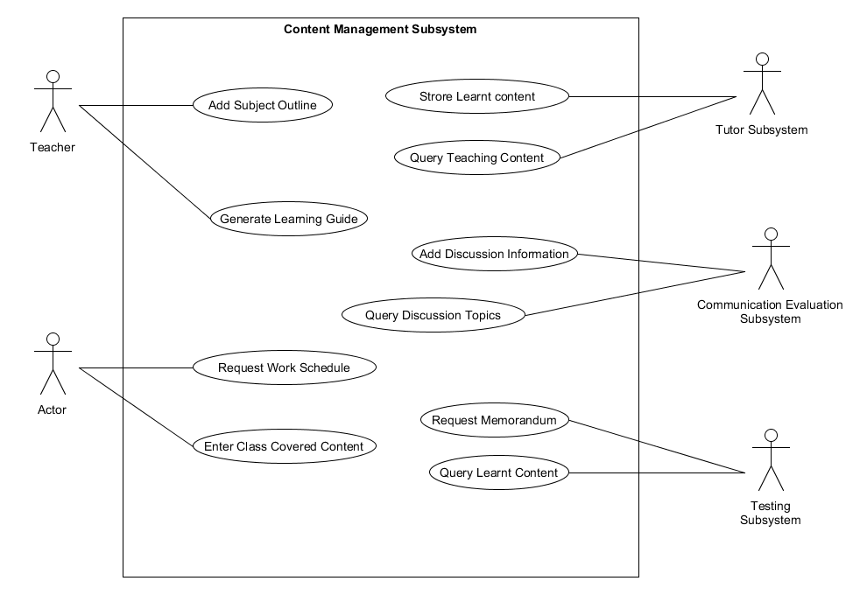

4.5 Mark Records Subsystem

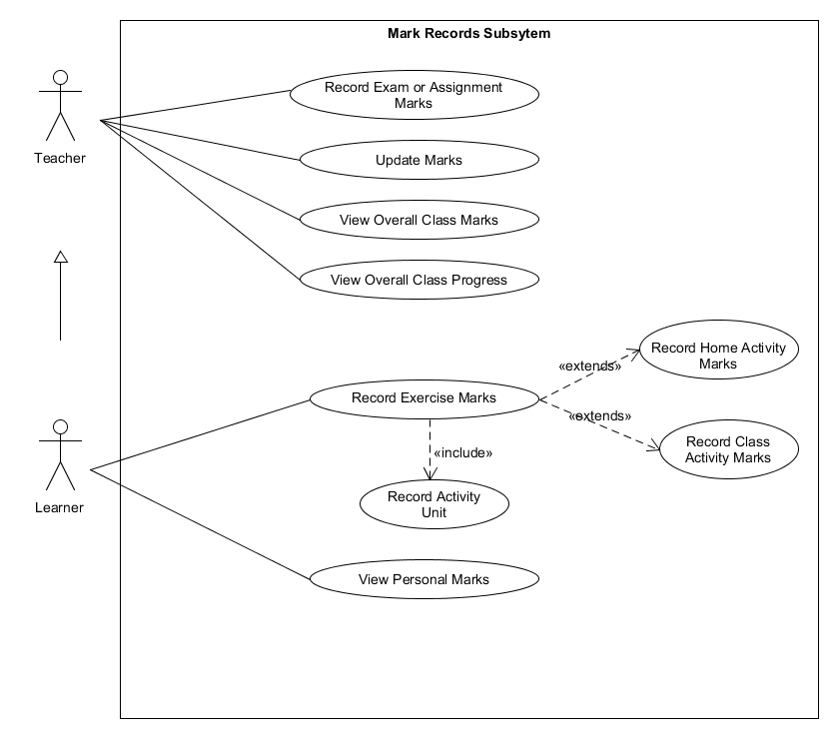

4.6 Marking Subsystem

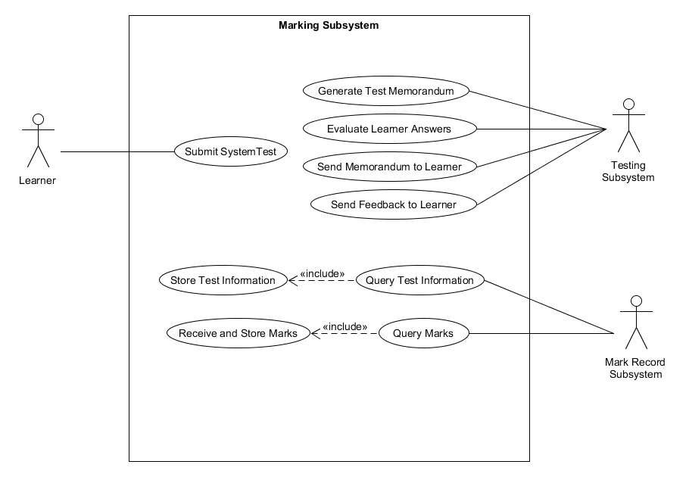

4.7 Online Activity Subsystem

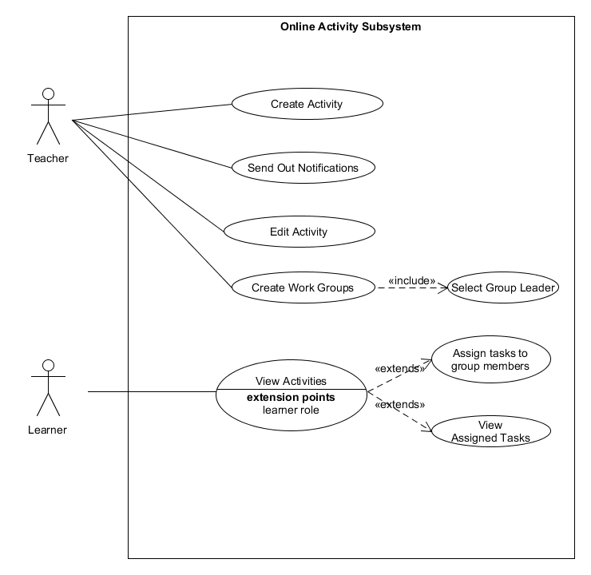

4.8 Performance Forecast Subsystem

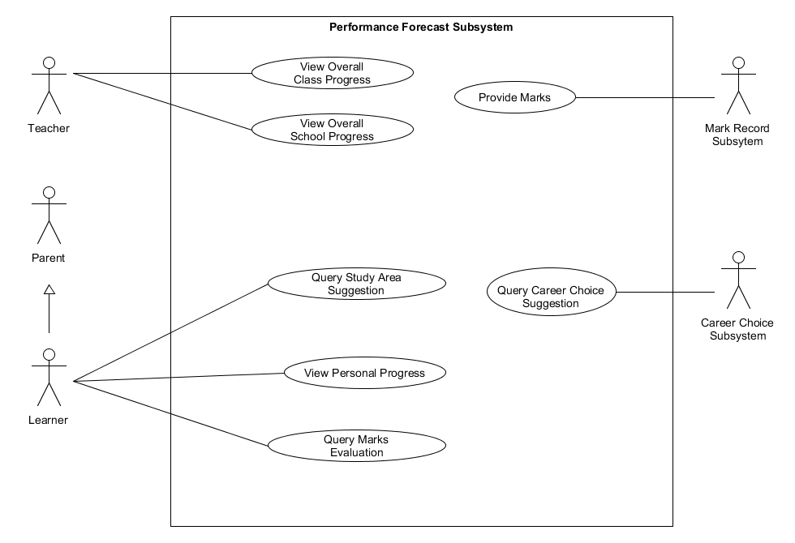

4.9 Registration Subsystem

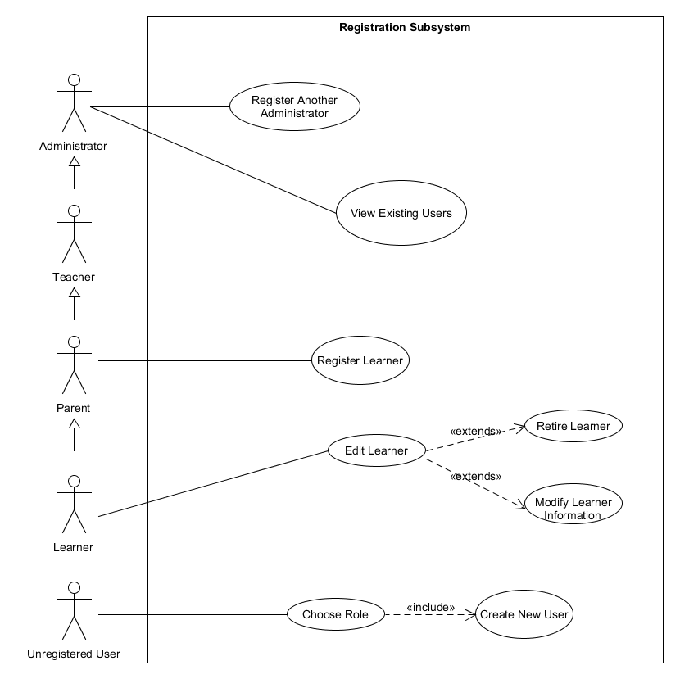

4.10 Tutor Subsystem

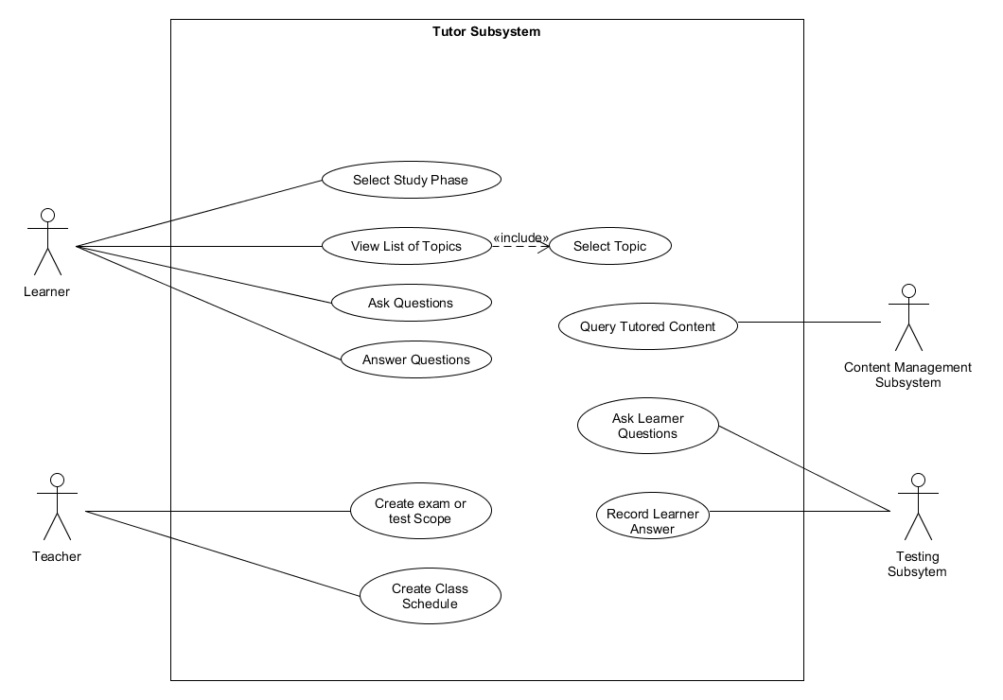

5. Use Case Description

**5.1.1 Class Management Subsystem.**

Use Case: Mark Attendance

1. Learner goes to attendance register page.
2. System display a form to confirm presence in class.
3. Learner marks absent or present for class.
4. System validates location of the learner if present.
5. System logs the query for teacher to process.

Use Case: View Learners in Class.

1. Teacher goes to class page.
2. Teacher goes to learners’ page.
3. System displays the list of learners in class.
4. Teacher views the list of learners in class.
5. Teacher saves the attendance of learners.
6. System logs and save attendance of learners.

Use Case: Edit Class

1. Teacher goes to class page.
2. System display options for teacher to select.
3. Teacher select option to work with.
4. Teacher make modification to the selected option.
5. System verifies the change.
6. Teacher saves the changes in database.
7. System logs and saves the change.

Use Case: View participating teachers.

1. Teacher goes to class page.
2. System displays options for teachers to work with.
3. Teacher selects the teachers option.
4. System loads the list of teachers teaching same subject and their progress.

Use Case: Add Learner to Class.

1. Teacher goes to create class page and fills in information.
2. Teacher goes to add learners option.
3. System list all learners at that school in that grade and subject.
4. Teacher adds learners who will participate in their class.
5. Teachers saves added learners to class.

Use Case: Add participating teachers.

1. Teacher goes to create class page and fills in information.
2. Teacher views the list of teachers teaching the same subject.
3. Teacher selects other teachers to add to class.
4. Teacher saves the added teachers to class.
   * 1. **Communication Subsystem**

Use Case: Send out notifications.

1. Teacher goes to notice board.
2. Teacher types in a notice.
3. Teacher saves and sends the notice.

Use Case: Send message to parent.

1. Teacher goes to messages.
2. Teacher views the list of people in the message list.
3. Teacher selects parent to message.
4. Teacher types in a message.
5. Teacher sends a message.

Use Case: Receive learner question.

1. Teacher goes to learners’ page.
2. Teacher views the learners with query flag in the list.
3. Teacher selects the learner to respond to.
4. Teacher types in a response.  
   Teacher sends a response.

Use Case: Update Notification.

1. Teacher goes to notice board. Teacher views the list of sent out notifications.
2. Teacher selects a notice to modify.
3. Teacher modifies the notice.
4. Teacher saves the notice.

Use Case: Send message to teacher.

1. Parent goes to the messages page.
2. Parent views the list of messages.
3. Parent selects the teacher to message.
4. Parent types in a message.
5. Parent sends a message to teacher.

Use Case: View Notifications.

1. Parent goes to the notice board.
2. Parent views the teacher notifications.

Use Case: Send learner question.

1. Learner goes to the tutor page.
2. Learner asks a question to the system.
3. Depending on question complexity, tutor sends the question to the teacher.
   * 1. **Communication Evaluation Subsystem.**

Use Case: Review Learner’s points.

1. Teacher goes to learners’ page.
2. Teacher selects a learner.
3. Teacher views learner profile.
4. Teacher selects online activity marks.
5. Teacher views the marks and average points for that learner.

Use Case: Create a discussion activity.

1. Teacher goes to learners’ page.
2. Teacher goes to discussion page.
3. Teacher creates a discussion.
4. Teacher posts a discussion for learners.

Use Case: Engage in discussion.

1. Learners goes to discussion board.
2. Learners views the discussion.
3. Learner selects a topic to make a remark on.

3a. Ask a question.

1. Learner clicks the question tag.

2. Learner types in a question.

3. Learner sends a question.

3b. Make a counter point.

1. Learner clicks counter point tag.
2. Learner types a counter point.
3. Learner sends the counter point.

Use Case: Make Comments.

1. Learner goes to the discussion board.
2. Learner views points made by other learners.
3. Learner opens a comment tag.
4. Learner types a feedback to the points made.

**Content Management Subsystem**

Use case: Add Subject Outline

1. Teacher goes to the add subject outline.
2. Teacher enters the outline of that subject.
3. System saves the information about the subject outline.

Use case: Generate Learning Guide

1. Teacher goes to generate learning guide.
2. Teacher enters the all the information about that subject.
3. Teacher enters the dates for tests and assignments.
4. System saves the information into one document.
5. System makes the learning guide available to the learners.

Use case: Request Work Schedule

1. Learner goes to Request work schedule
2. Learner confirms the grade.
3. System displays the work schedule.

Use case: Enter Class Covered Content

1. Learner goes to the class covered content.
2. Learner clicks enter class covered content.
3. Learner enters the content they have covered so far.

**5.1.5 Mark Records Subsystem.**

Use Case: Record exam or assignment marks.

1. Teacher goes to the learners’ page.
2. Teacher selects marks option.
3. Teacher select activity type for marks.
4. Teacher enter the marks for the assignment for each learner.
5. System creates or modify the underlying spreadsheet to record marks.

Use Case: Update marks.

1. Teacher goes to learners’ page.
2. Teacher opens the marks page.
3. Teacher select a mark record to modify.
4. Teacher edit the change.
5. Teacher saves the change.

Use Case: View Overall class marks.

1. Teacher goes to learners’ page.
2. Teacher clicks marks page.
3. System views average mark for each subject for every learner.

Use Case: View overall class progress.

1. Teacher goes to learners’ page.
2. Teacher clicks class statistics page.
3. Teacher view graphs on whether learners are improving or not.

Use Case: Record exercise marks.

1. Learner goes to marks page.
2. Learner creates a new activity and provides information.
3. Learner records a total mark.
4. Learner records an achieved mark for that task.

4a. Record home activity marks.

1. Learner marks the activity as homework.

4b. Record class activity marks.

1. Learner marks the activity as class work.

Use Case: View personal marks.

1. Learner goes to marks page.
2. Learner views marks for all activities sorted by date, or activity type.